Game Video Setting UXR

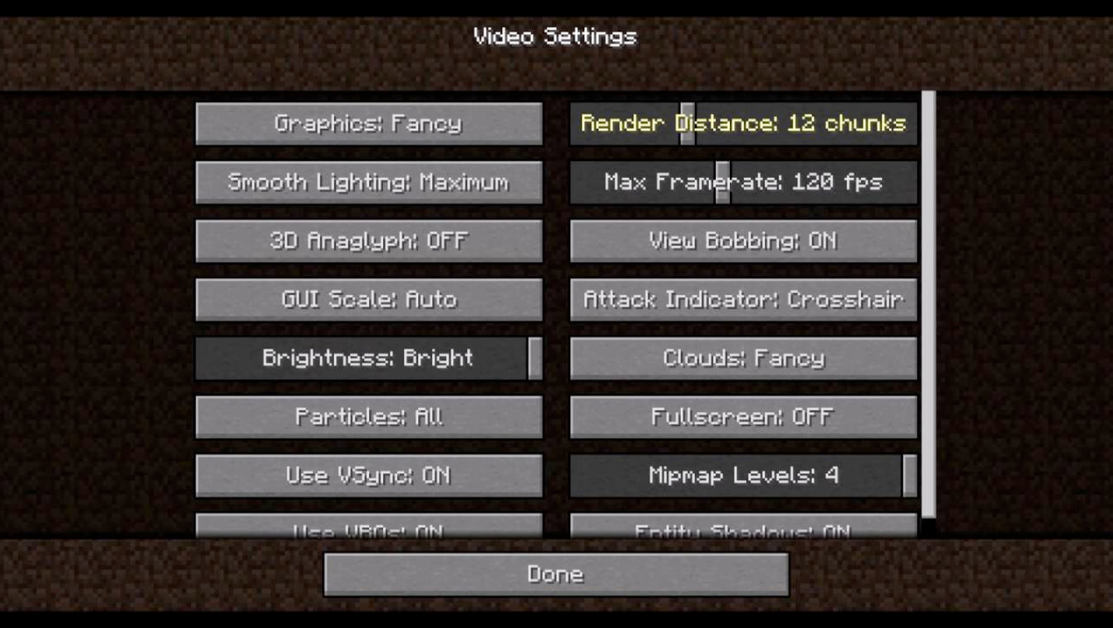

Objective: I will be redesigning Minecraft’s Video Settings pictured above.

Issue: The first problem I see here is that there is a huge issue with visual chunking. This two column grid has everything evenly spaced out. Nothing is clumped together and there is no way to tell what things have similar ideas or related effects. I also decided to order the items based on importance to the user and establish a visual hierarchy.. Things that affect smooth gameplay come first.

Proposal

I would group these items together:

* Render Distance, Entity Distance
  + Distance rendering off two different items
* Graphics, Max Framerate
  + Things that have a big toll on graphics
* Fullscreen Resolution, Fullscreen (on and off)
  + Effects Window Size
* Distortion Effects, FOV Effects, Particles
  + Effects
* View Bombing, Gui Scale, Attack Indicator
  + Visual/Gui
* Brightness, Smooth Lighting
  + Things that effect lighting
* Biome Blend, Clouds Off, Entity Shadows
  + Things that have an effect on certain visibility or spawning of objects in game.

Coincidentally there are two or three things grouped together which makes for a really pleasant UI. I put them all into an example table here on the left, and an example of the spacing on the right.

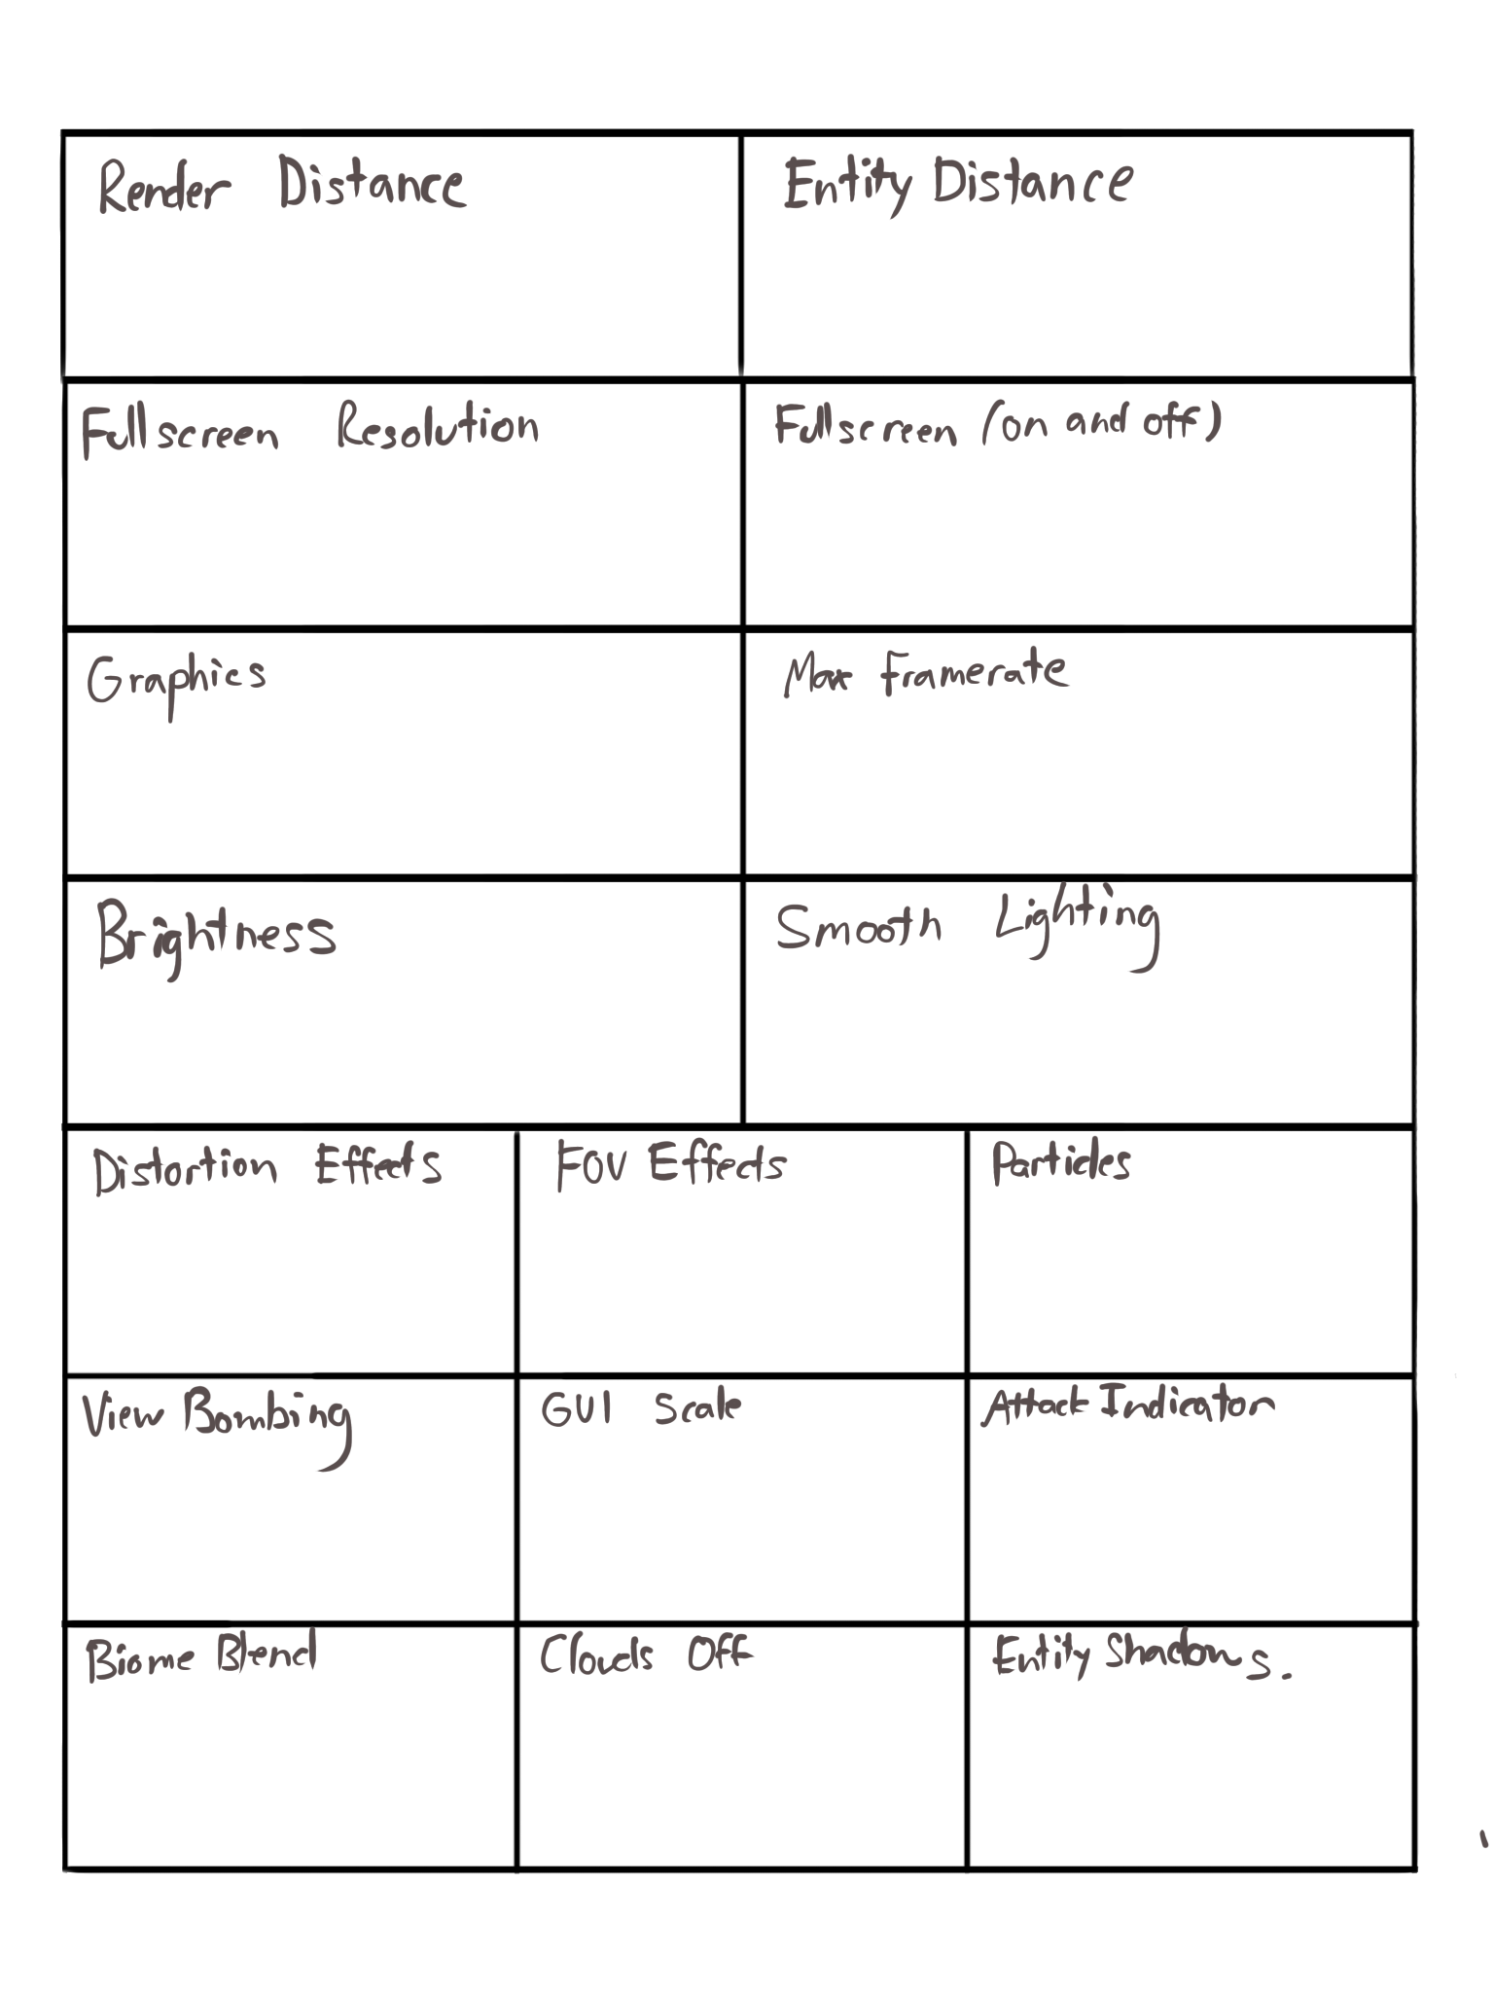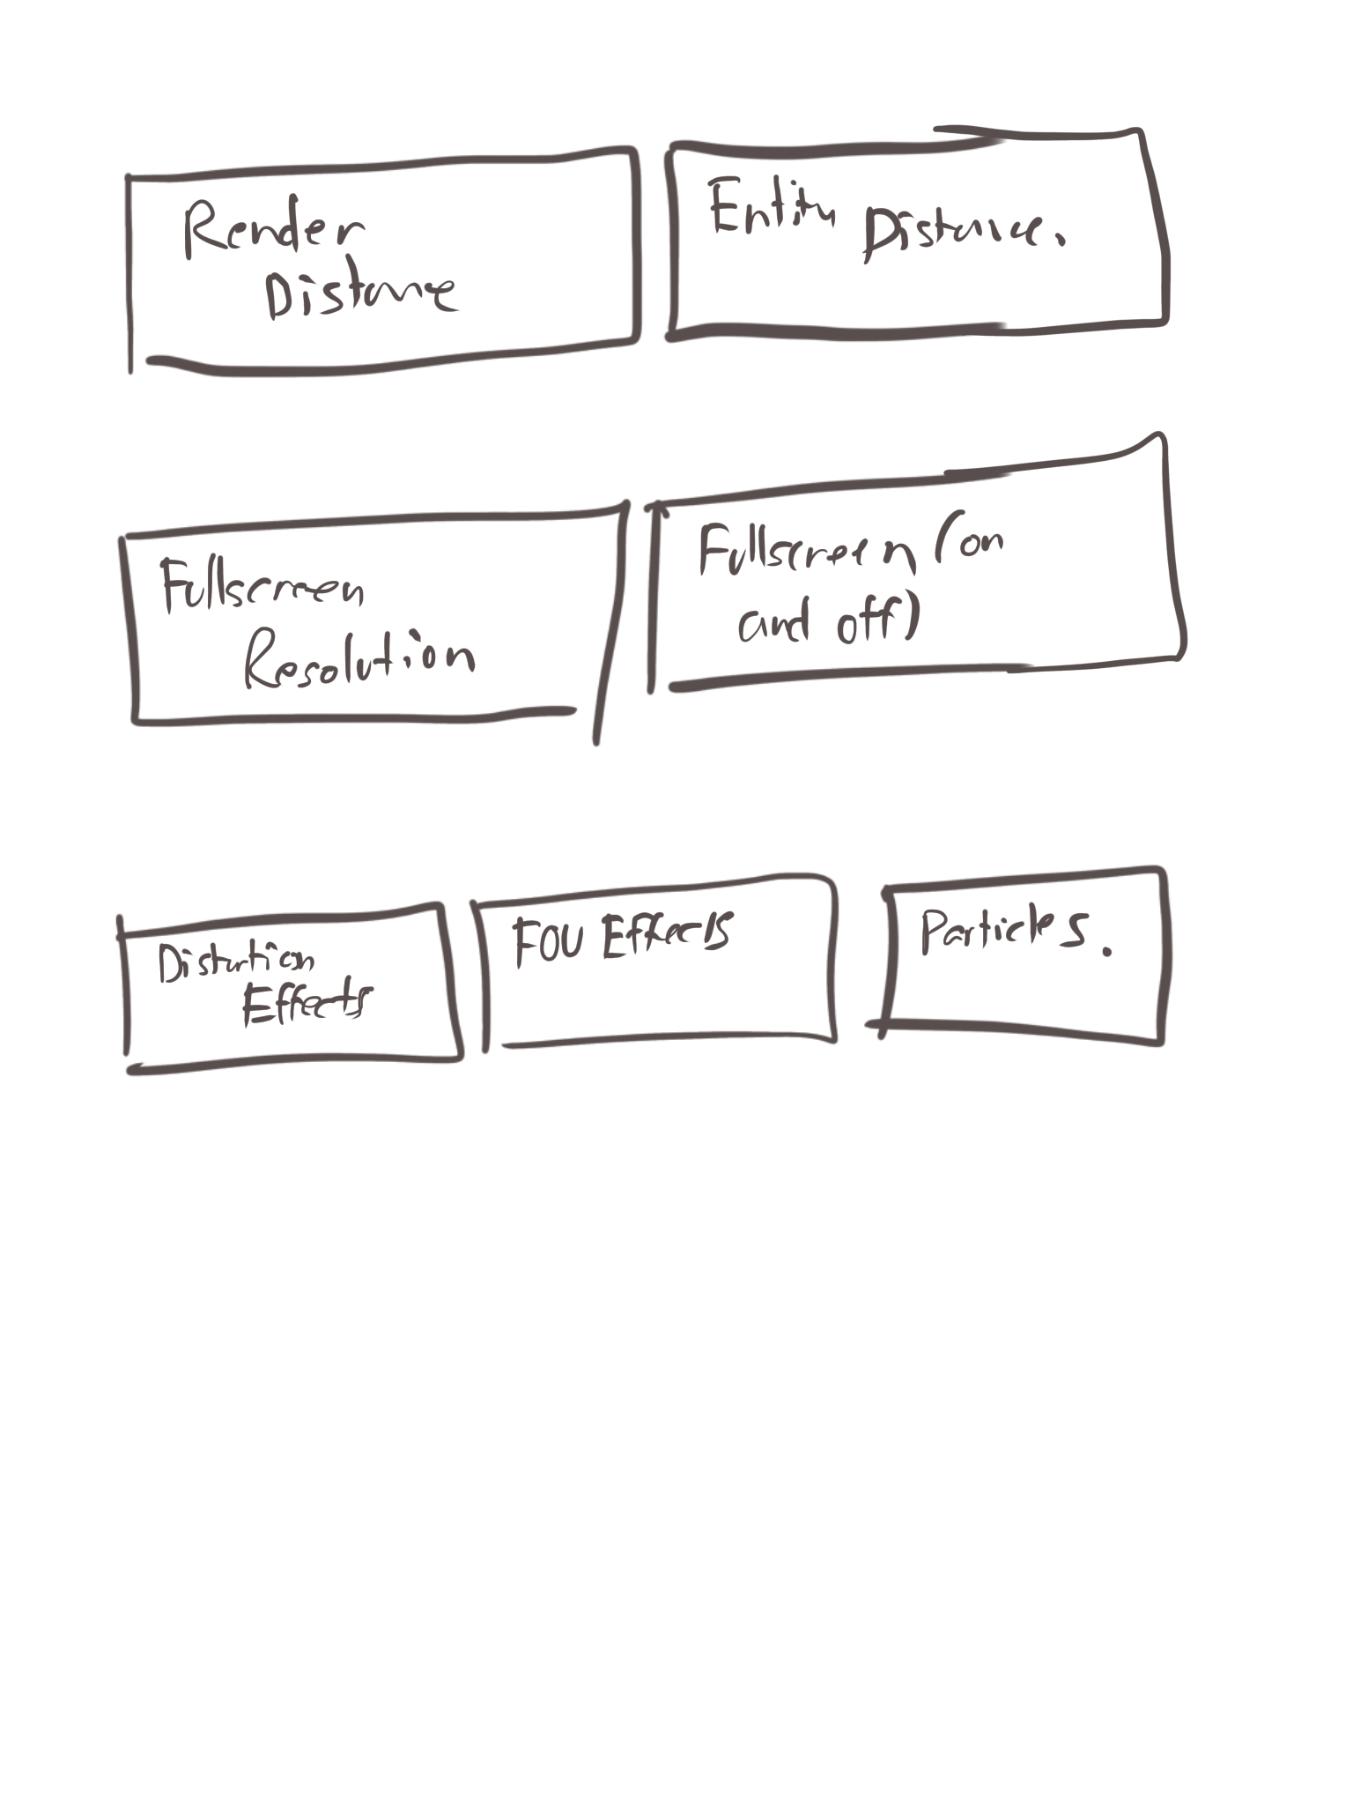

Minecraft is targeted towards children and I think that for some of these options signifiers are necessary. In the most updated version of minecraft there is a blurb explaining some of the more complex issues. I posted a screenshot of what that looks like below. I would have one of these hover blurbs on all of the complex settings options except the ones that are like brightness, clouds, and fullscreen.

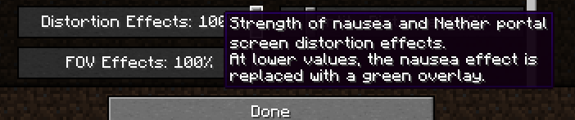

I think the next step here is to make some options more intuitive and fit into the mental models people have.

A good example is that some of the options can be replaced with symbols.

There could be a brightness slider like the one below which many people associate the sun symbol with brightness.

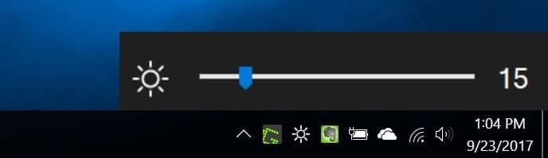

Conversely I think a preview image to look at would greatly help users visualize what is happening. As of right now the only feedback the user has is “I clicked a button and the button went down”.

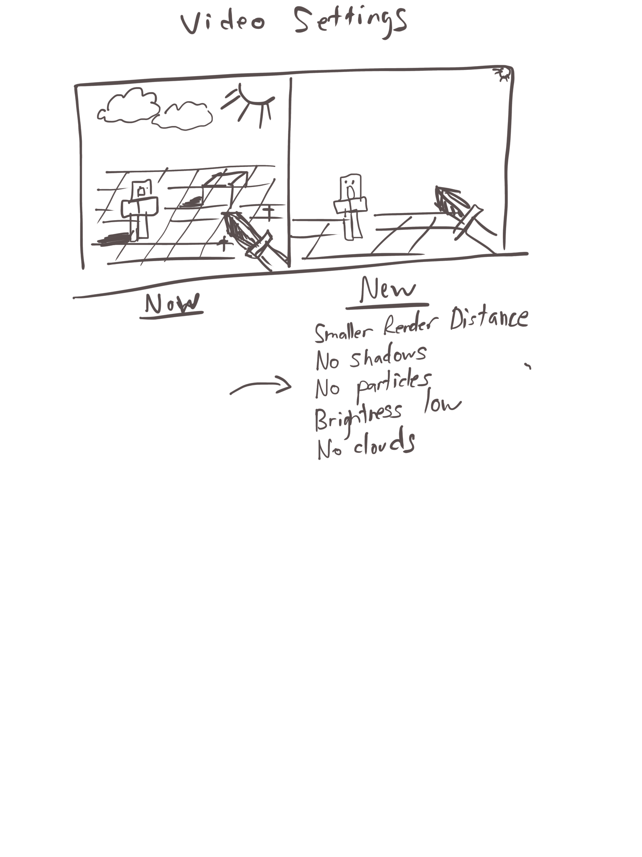

This allows the user to visibly see how the options impact their game experience.

According to user research in this article here <https://feedback.minecraft.net/hc/en-us/community/posts/360054902732-An-option-to-use-the-old-view-bobbing-in-the-Video-settings-menu>

I think it would be worth putting an older version of view bobbing because of how many different and more effective options it had.

I think the last thing minecraft menus have issues with is how the options affect user flow and gameplay experience. To get to the video effects settings you need to press esc → options → and then video settings. I think it takes too long and there are too many options to get through until you get to see video settings. If a user just wants to slightly turn down the brightness there is a lot of user input required to take them out of the game and alter the gameplay. I am not sure if this is due to how minecraft is coded or how the rendering in the game works, but I think that some options should take less time to get to. If there was an option to press ctrl B and toggle through different brightness settings I think that would greatly improve the amount of time players stay

engaged in the game and less time they spend fiddling through menus.

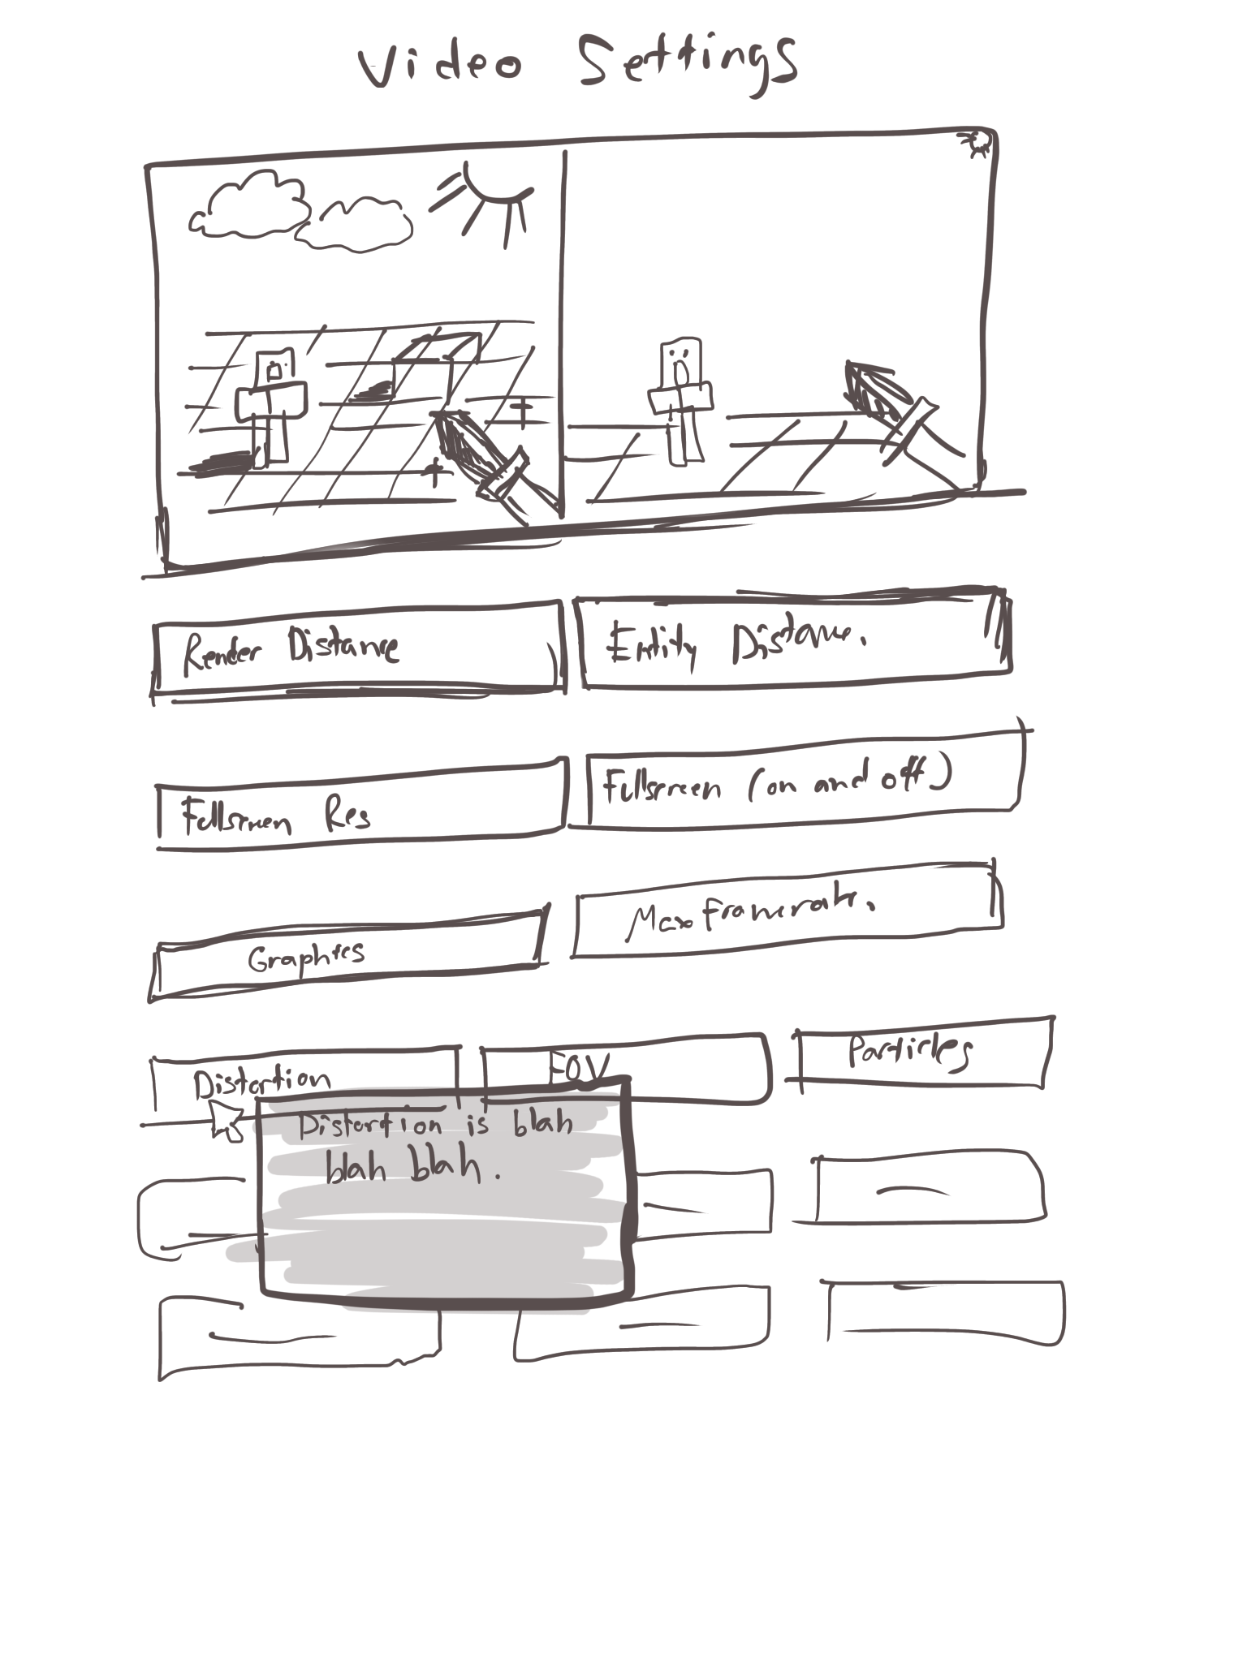

So right now our UI should look like the image above. I took out the brightness setting because I would prefer for that to be more accessible outside of an options menu using a visual indicator. The last thing this needs is some color. I gave graphics fast, medium, and slow the same colors as a traffic light because that’s something people will recognize and have a mental model of. The last thing this UI needs to do is have some polish and make itself look more visually appealing. It can at least have a visceral design. I don’t think it will have behavioral or reflective design because Minecraft’s menu options are something people are so familiar with and already have some vague attachment to. Change in any UI usually has some negative feedback so I doubt people will have a positive emotional reaction at first. Below is my final draft of what a revamped UI would look like for Minecraft video settings.